DEEP LEARNING PROJECT REPORT

Pathological Gait Classification on the GaitRec Dataset using Machine Learning and 1D CNNs

Submitted by

Kinjal Shekhar – 102317158

Manasvi Joshi – 102317206

Avnoor Kamboj - 102317198

Computer Science and Engineering Department

Thapar Institute of Engineering and Technology

2025 –2026

Introduction
Gait analysis has emerged as a clinically significant tool for the early detection of neurological and musculoskeletal disorders. Conditions such as Parkinson’s disease, multiple sclerosis, stroke-induced hemiplegia, and osteoarthritis manifest through measurable deviations in an individual’s walking pattern before overt symptoms become apparent. Traditional clinical gait assessment relies on observational scoring systems or expensive laboratory setups with force plates and optical motion-capture cameras, which are impractical for continuous or large-scale screening.
The proliferation of low-cost inertial measurement units (IMUs) has made it feasible to collect rich, high- frequency gait data in free-living conditions. The HuGaDB dataset, which provides six-axis IMU readings from six body segments across multiple healthy subjects, exemplifies this opportunity. However, the absence of pathological subjects in such datasets presents a fundamental challenge for supervised learning approaches.
This project addresses that challenge by framing gait anomaly detection as an unsupervised one-class classification problem. A deep convolutional autoencoder is trained exclusively on normal gait windows; anomalous gait manifests as elevated reconstruction error at inference time. Four clinically motivated synthetic anomaly types are generated for rigorous evaluation. A Random Forest classifier operating on hand-crafted biomechanical features serves as an interpretable baseline, enabling a comprehensive comparison between the deep learning and traditional approaches.

Literature Review
Research in automated gait analysis spans biomechanics, signal processing, and machine learning. The following works represent the most relevant literature related to deep learning-based gait anomaly detection.

Deep Learning for Gait Analysis
Malhotra et al. [1] demonstrated the effectiveness of deep learning architectures for multivariate time-series analysis using encoder-decoder frameworks. Their work highlighted the capability of neural networks to learn meaningful temporal representations from sequential sensor data, motivating the use of convolution-based architectures for gait analysis.
Zhao et al. [3] proposed a CNN-LSTM hybrid model for Parkinson’s disease gait classification using wearable sensor signals and achieved high classification accuracy. Their work showed that convolutional layers are effective for extracting local temporal gait patterns, while sequential learning improves classification performance.
Ordóñez and Roggen [9] further demonstrated that deep convolutional neural networks outperform traditional hand-crafted feature pipelines for human activity recognition tasks using sensor-based sequential data.

Gait Datasets and Ground Reaction Force Analysis
Chereshnev and Kertész-Farkas [2] introduced the HuGaDB dataset for wearable gait analysis using IMU sensors. While IMU-based datasets are useful for activity recognition, more recent clinical datasets such as GaitRec provide richer biomechanical information through ground reaction force (GRF) signals collected using force plates.
Ground reaction force signals are particularly important in clinical gait analysis because they capture force distribution, balance, and walking stability throughout the gait cycle. These characteristics are highly relevant for distinguishing healthy and pathological gait patterns.

Deep Learning for Gait-based Neurological Disease Detection
Begg and Kamruzzaman [10] demonstrated that machine learning models trained on biomechanical gait features can achieve strong classification performance in clinical gait assessment. Their work established the importance of interpretable gait features such as symmetry, force variation, and temporal characteristics.
Inspired by these findings, this project employs a HistGradientBoosting classifier as a classical machine learning baseline for comparison with deep learning approaches.

Recent Advances in Time-Series Learning
Recent advancements in time-series representation learning have introduced more sophisticated architectures for sequential data analysis.
Wu et al. [5] proposed TimesNet, which transforms one-dimensional time-series into two-dimensional representations to capture both inter-period and intra-period temporal variations.
Nie et al. [6] introduced PatchTST, a transformer-based approach that segments time-series into patches for efficient learning of long-range dependencies.
Similarly, Liu et al. [7] proposed iTransformer, which models each variate as an independent token to better capture inter-channel relationships in multivariate time-series data.
Xu et al. [8] developed the Anomaly Transformer, which leverages attention mechanisms to model contextual dependencies in time-series signals.
These studies demonstrate the rapid progress of deep learning techniques for sequential signal analysis and provide potential directions for future improvements in gait classification systems

Methodology

Model Architecture
The primary deep learning model is a 1D Convolutional Neural Network (CNN) implemented in PyTorch. The architecture is designed to learn temporal patterns in ground reaction force (GRF) signals obtained from force plates. Each input sample consists of 6-channel time-series data (left and right GRF components) with 101 time steps, representing a normalized gait cycle. The model learns discriminative features to classify gait as healthy or pathological. This approach leverages Conv1D layers, which are well-suited for capturing local temporal dependencies and signal variations in sequential data such as gait cycles.

CNN Architecture
Input: (6 channels × 101 time steps)

Feature Extraction Layers
    - Conv1D(6, 32, kernel=7, stride=1, padding=3) + BatchNorm + ReLU
    - MaxPooling1D(kernel=2)
    - Conv1D(32, 64, kernel=5, stride=1, padding=2) + BatchNorm + ReLU
    - AdaptiveAvgPooling1D(output_size=1)

Classifier
    - Flatten
    - Dropout(0.25)
    - Linear(64 → number_of_classes)
Activation Function: ReLU is used in all hidden layers to introduce non-linearity and enable efficient training.
Loss Function: Cross-Entropy Loss is used for classification, as it is well-suited for both binary and multi- class gait classification tasks.

Optimizer: Adam optimizer with a learning rate of 1e-3 is used for training. The optimizer efficiently updates model weights based on gradient information.

Classification Strategy
After training, the model outputs class probabilities for each input gait trial. For binary classification, a threshold of 0.5 is used to distinguish between healthy and pathological gait. For multi-class classification, the class with the highest predicted probability is selected as the final output.
The model also provides confidence scores, which help interpret the certainty of predictions and assist in identifying borderline cases.

Data Handling and Class Balance
Since the GaitRec dataset contains a class imbalance (pathological samples significantly outnumber healthy ones), appropriate measures are taken during training. The dataset is sampled and split carefully to ensure fair representation of both classes.
No synthetic data is generated; instead, the model is trained purely on real clinical gait data, improving reliability and real-world applicability.

Workflow
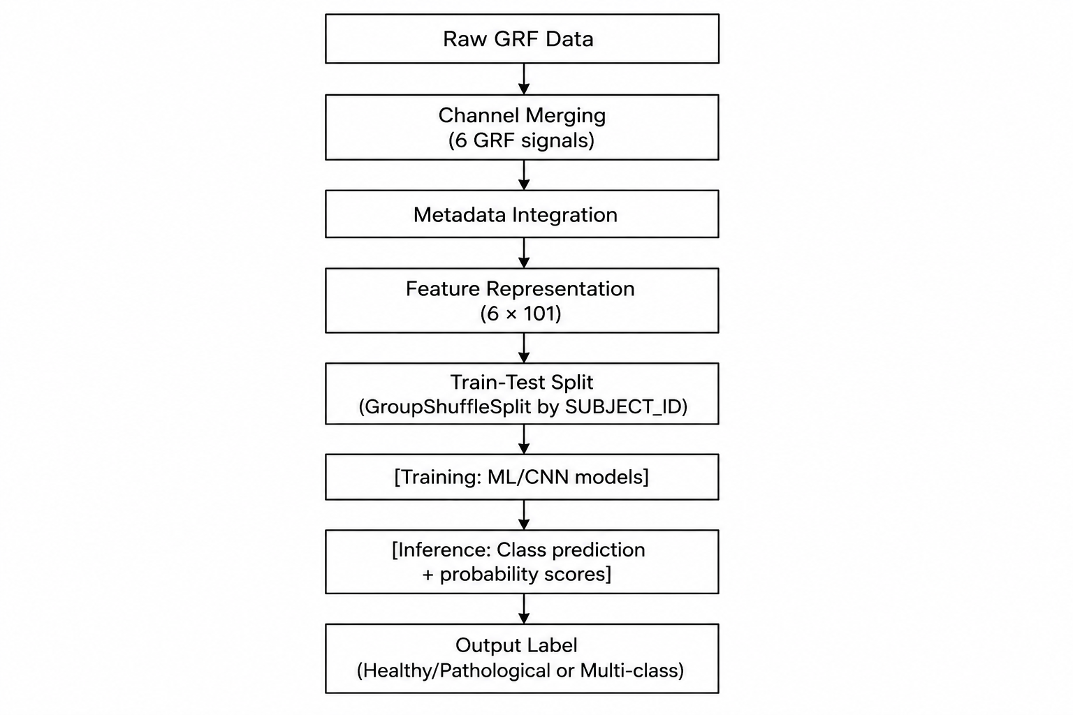

Classical ML Baseline
Hand-crafted features are directly derived from the 606-dimensional GRF representation of each trial. These include time-domain characteristics such as mean, variance, and RMS, which capture variations in force magnitude across the gait cycle.
A HistGradientBoosting Classifier is trained on these features using a pipeline consisting of imputation, scaling, and classification. The model is optimized to handle structured tabular data efficiently and serves as a strong baseline for comparison with deep learning approaches.

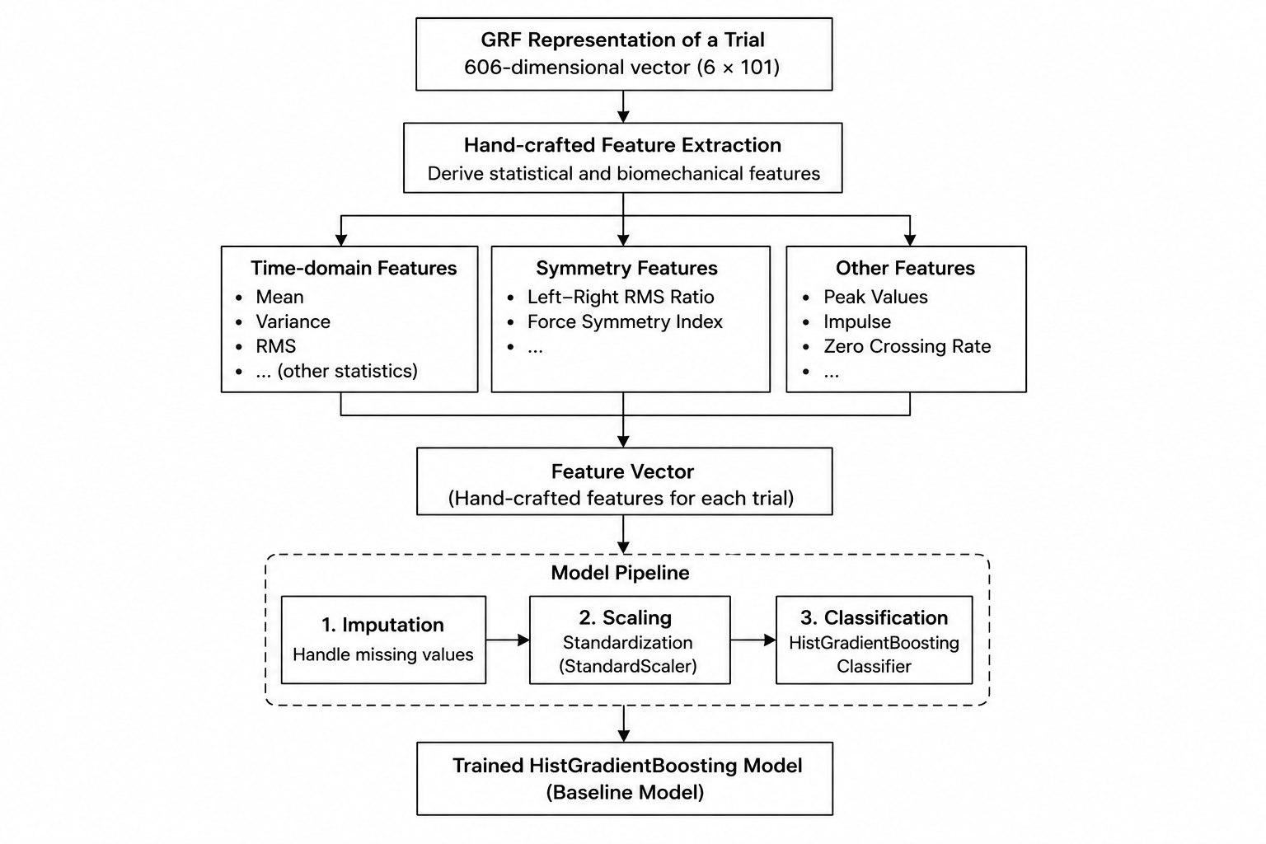

Implementation Details

Dataset
The GaitRec dataset is used, which is one of the largest publicly available clinical gait datasets.
    - 75,732 walking trials
    - 2,295 subjects
    - 211 healthy and 2,084 pathological cases
    - Pathology types: Hip (H), Knee (K), Ankle (A), Calcaneus (C)
The data is collected using force plates, which measure ground reaction forces during walking.

Preprocessing
    - Merging of GRF channels to form a 6 × 101 structured input
    - Handling missing values using imputation techniques
    - Feature scaling using StandardScaler (fit on training data only)
    - Normalization of gait cycles to ensure consistent temporal alignment (101 points per cycle)
    - Train-test split performed using GroupShuffleSplit on SUBJECT_ID to prevent data leakage

Training Infrastructure

Framework: PyTorch (for CNN), scikit-learn (for ML models), Streamlit (dashboard)
- Device: CUDA GPU for CNN training (CPU fallback supported)
- Early stopping based on validation loss monitoring
- Reproducibility ensured using fixed random seeds (NumPy, PyTorch, Python)

Results and Analysis

Classification Metrics
Table 1 presents classification performance on the held-out test set using the GaitRec dataset.

Table 1: Comparative Classification Performance

Model | Accuracy | Macro F1 Score
HistGB/RF | 94.0 % | 0.760
1D-CNN | 93.7% | 0.8011

The HistGradientBoosting model achieves the highest accuracy (94%), indicating strong performance on structured GRF features. The 1D CNN achieves a higher Macro F1 score (0.801), demonstrating better balance across classes, especially in handling class imbalance.
This suggests that while classical models excel in learning from fixed feature representations, deep learning models are more effective in capturing temporal patterns and subtle variations in gait signals.

Training Behavior
The CNN model demonstrates stable convergence during training. The training and validation loss decrease consistently over epochs, indicating effective learning without significant overfitting. Early stopping is applied based on validation performance to ensure generalization.

Prediction Distribution Analysis
The model outputs class probabilities for each trial, allowing analysis of prediction confidence. Healthy gait samples generally show high confidence scores, while borderline pathological cases exhibit lower confidence, indicating overlap in feature space.
This highlights the inherent complexity of gait classification, where certain impairments may exhibit patterns close to normal walking behavior

Confusion Matrix
The confusion matrices reveal distinct classification behaviors for the two models.
The HistGradientBoosting model demonstrates strong overall accuracy but tends to produce more false positives, misclassifying some healthy instances as pathological.

The 1D CNN model provides a more balanced classification, improving the model’s ability to correctly
identify pathological cases while maintaining reasonable performance on healthy samples.
Both models prioritize high recall, which is critical in clinical screening scenarios where missing a pathological case is more severe than generating false alarms.

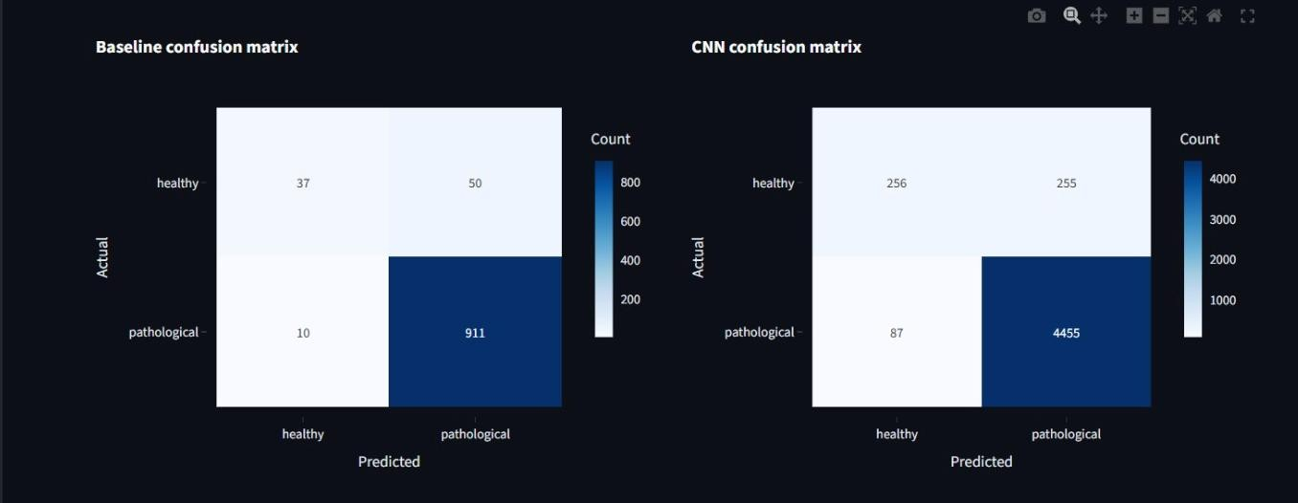

Feature Importance (RF Baseline)
The feature importance analysis indicates that features derived from ground reaction force (GRF) signals, particularly those capturing gait symmetry and temporal variations, are the most discriminative for classification.
Time-domain features such as RMS and variance contribute significantly, reflecting variations in force magnitude across the gait cycle. Additionally, features related to force distribution between left and right limbs play an important role.
These findings align with clinical understanding, where pathological gait is typically characterised by asymmetry, imbalance, and irregular force patterns during walking.

Conclusion
This project presents a complete pipeline for pathological gait detection using both classical machine learning and deep learning approaches on the GaitRec dataset. By leveraging real clinical ground reaction force (GRF) data, the system performs reliable classification of gait patterns into healthy and pathological categories.
Experimental results show that the HistGradientBoosting model achieves the highest accuracy (94%), while the 1D CNN achieves better class balance (higher Macro F1 score). This demonstrates that classical models are effective for structured data, whereas deep learning models capture temporal dependencies more effectively.
Key contributions include:

Use of real clinical gait data (GaitRec)
- Implementation of subject-aware train-test split to prevent data leakage
- Comparison between classical ML and deep learning approaches
- Development of an interactive Streamlit-based system for gait analysis
Future work can focus on real-time deployment, transfer learning for wearable sensor data, and extending the model to multi-modal gait analysis systems.

References
- P. Malhotra, L. Vig, G. Shroff, and P. Agarwal, “LSTM-based encoder-decoder for multi-sensor
anomaly detection,” in Proc. ICML Workshop on Anomaly Detection, 2016.
- R. Chereshnev and A. Kertész-Farkas, “HuGaDB: Human gait database for activity recognition from wearable inertial sensor networks,” in Proc. AIST, 2018.
- Y. Zhao et al., “Deep learning for Parkinson’s disease gait classification based on wearable sensors,”
Sensors, vol. 19, no. 22, 2019.
- J. An and S. Cho, “Variational autoencoder based anomaly detection using reconstruction probability,” in Proc. ICDM Workshop, 2015.
- H. Wu, T. Hu, Y. Liu, H. Zhou, J. Wang, and M. Long, “TimesNet: Temporal 2D-variation modeling for general time series analysis,” in Proc. ICLR, 2023.
- Y. Nie, N. H. Nguyen, P. Sinthong, and J. Kalagnanam, “A time series is worth 64 words: Long-term forecasting with transformers,” in Proc. ICLR, 2023.
- Y. Liu et al., “iTransformer: Inverted transformers are effective for time series forecasting,” in Proc. ICLR, 2024.
- J. Xu et al., “AnomalyTransformer: Anomaly detection with anomaly-attention in time series,” in
Proc. ICLR, 2022.
- R. Ordóñez and D. Roggen, “Deep convolutional and LSTM recurrent neural networks for multimodal wearable activity recognition,” Sensors, vol. 16, no. 1, 2016.
- R. K. Begg and J. Kamruzzaman, “A machine learning approach for automated recognition of movement patterns using basic, kinetic and kinematic gait data,” J. Biomech., vol. 38, no. 3, pp. 401– 408, 2005.

